# Code Analysis / White-box Testing:

(Describe, in words or code, the step-by-step logic for up to three tests - manual or automated - that would have caught the bugs.)

* What are the three bugs?
* Why doesn't the test find them?

1. Code is adding recipient only if no successful messages are there.



* Test was not able to find them as we are just checking failed messages count in testcase.

1. The method getHas permissionToModifyReceipients() will never be checked as it’s a OR condition and we are passing same user object so always true .

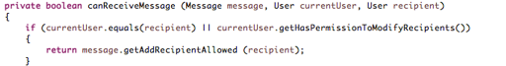

* Test was not able to find them as we are passing same user object.

1. Even if both conditions are false by default its returning true. So we always have a successful message.

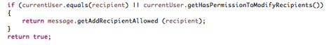

* Test was not able to find them as its always returning true.

To catch the issues we can write multiple test cases with different scenarios:-

Passing All successful message.

Passing only fail messages

Passing different currentUser and reciepientuser.